# Activities If the Australian CDC does this…

## Build rapid and comprehensive data for actionable insights

* Develop a new national communicable disease surveillance system
* Strengthen public health data resources
* Accelerate access to data to support decision-making
* Advance interoperability of data across jurisdictions and sectors

## Develop partnerships for enabling data governance

* Enable linkage of person level data
* Support multidirectional data sharing
* Develop framework for use of novel data sources

## Deliver enhanced data to support health equity

* Develop architecture to analyse disease burden and severity across different populations
* Support culturally appropriate governance of data

## Build public trust in CDC data use

* Cultivate and maintain an authorising environment for CDC data and analytical activities

Highly skilled workforce that uses contemporary data skills and tools

* Support robust handling and use of data in line with community expectations and legislated responsibilities
* Facilitate transparency in decision-making

# Outcomes … then we can expect…

## Faster, detailed, coordinated national data for actionable insights.- Interoperable, cloud based national surveillance and analysis system- Improved collection, quality, completeness and consistency of priority data-Architecture for analysis of social, behavioural, economic, environmental & wider Determinants data -Multi-way data sharing across jurisdictions and sectors

# Impacts … to support our ultimate goals

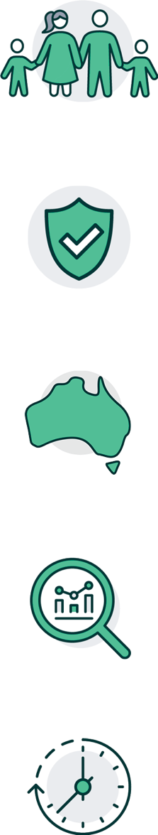Better health outcomes for all Australians

The Australian CDC is a trusted authority of evidence-based advice

National consistency in public health advice and coordinated action

Accurate, evidence-based advice for effective, equitable, efficient and proportionate public health actions

Rapid identification of emerging public health issues

# Summary

The Australian CDC wants to improve how data is used so that we can support better health for all Australians.

The Preliminary Data Strategy outlines the activities the CDC will take to improve the role of data in public health decisions across four main priority areas, including:

1. **Build rapid and comprehensive data for actionable insights**

These activities will support improvements in how the CDC collects data and how it is combined with other data so that we can better understand the whole picture. We want to be able to get these insights faster so that we can give advice that will benefit all Australians in a timely way. A main output for this priority is developing a new National Public Health and Surveillance System which will allow for fast data flows – this is important in emergency situations.

1. **Develop partnerships for enabling data governance**

These activities will support improvements in how we share and link data from a range of sources. Developing partnerships with key stakeholders and improving how we share data will ensure that we use it efficiently to prepare, respond, and adapt to public health issues.

1. **Deliver enhanced data to support health equity**

These activities will support improvements in how we understand health impacts and how they vary across different populations. This will ensure we give clear advice to improve health equity, and ensure we use data in a culturally appropriate way.

1. **Build public trust in CDC data use**

These activities will support improvements in transparency about to how the CDC will use data. We want to ensure that we use and report on data use in line with public expectations. Evidence for public health decisions will be publicly accessible and clearly communicated for all population groups.

The results from these activities will ensure we can use data to supply fast and transparent insights into public health concerns.

This will ensure that we can rapidly know about public health issues of concern, deliver informed and evidence-based advice on public health actions, maintain trust with the Australian population and stakeholders, and improve the health of Australians.

# Glossary

| **TERM** | **DEFINITION** |
| --- | --- |
| DATA LINKAGE (or PERSON-LEVEL RECORD LINKAGE) | Data linkage refers to the joining (linking) of information from two or more different data sources believed to relate to the same entity (for example, to the same individual or the same institution). This linkage can yield more information about the entity and, in certain cases, give a time sequence. The term is synonymous with ‘record linkage’ and ‘data integration’. |
| INTEROPERABILITY | Interoperability refers to the ability of different information systems, devices and applications (‘systems’) to access, exchange, integrate and use data in a coordinated way. |
| METADATA | Metadata (or data about data) refers to information about how the data are defined, collected, and structured. Metadata provides meaning and context which helps to interpret the data. |
| MULTIDIRECTIONAL DATA SHARING | Multidirectional data sharing refers to the sharing of data in back and forth. It describes a mutual benefit to the data sharing, in which both parties will have access to the data for public health purposes. |
| DATA RESOURCES | Data resources refer to data, data systems, databases, and data collections. |
| NOVEL DATA SOURCES | Novel data sources are new data which may arise (for example a new pathogen). |
| ARCHITECTURE | Data architecture consist of models, policies, rules, and standards that govern which data is collected and how it is stored, arranged, integrated, and put to use in data systems |