Achievements of the first year of the
interim Australian Centre for Disease Control

The interim Australian Centre for Disease Control (CDC) was established on 1 January 2024 as the first step in the Government’s phased establishment of an Australian CDC. In the first year of the interim CDC, we have delivered work to improve the health of Australians and strengthen preparedness to respond to future health emergencies, including:
 | Launched the Australian National Surveillance Plan for COVID-19, Influenza, and RSV and delivered fortnightly reporting on rates of these respiratory diseases.
 | Supported Australia’s preparedness for a possible outbreak of the H5N1 strain of avian influenza, contributing to a whole-of-government One Health approach.
 | Delivered the Ninth National HIV Strategy 2024–2030 to guide Australia's path to eliminate HIV.
 | Launched the BeforePlay STI campaign, the first national STI campaign in many years, to promote safe sex.
 | Launched the National Occupational Respiratory Disease Registry to inform policies and actions to reduce occupational diseases.
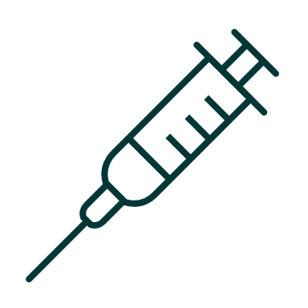 | Developing the National Immunisation Strategy 2025–2030, the Strategy is expected to be released in early 2025.
 | Held and participated in national preparedness exercises for complex, compounding crises with health consequences.
 | Delivered the Preliminary Data Strategy for the Australian CDC, outlining the actions being taken to establish the Australian CDC as a data-driven organisation.
 | Established the One Health Unit to increase national capacity to address health risks at the intersection of animal, environmental, and human health.
 | Established the Health Security Unit to work with Australian Government intelligence sector, focused on early detection and analysis of threats.
 | In 2025, we will continue to deliver work to support the health of Australians and progress towards the establishment of the Australian CDC.

